
SHIRE HIGHLANDS EDUCATION DIVISION
2026 MALAWI SCHOOL CERTIFICATE OF EDUCATION MOCK
EXAMINATION

MATHEMATICS
Subject Number: M131/I
Wednesday, 18th March, Time Allowed: 2 hours
8:00 - 10:00 am

PAPER I
(100 Marks)

INSTRUCTIONS

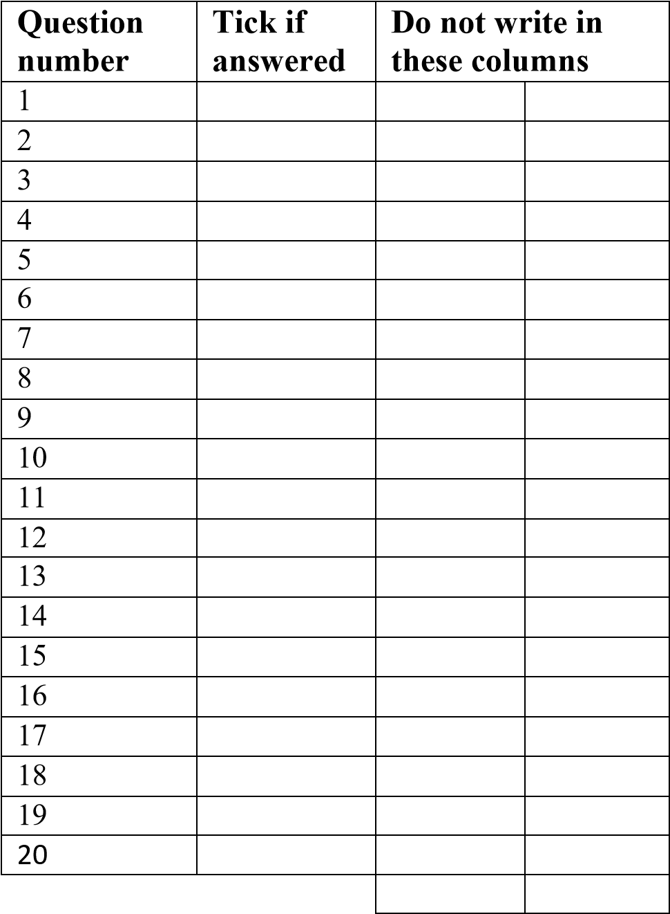
- This paper contains 11 printed pages. Please check.
- Answer all the 20 questions in this paper.
- The maximum number of marks for each answer is indicated against each question.
- Scientific calculators may be used.
- All working must be clearly shown
- Write your Examination Number at the top of each page of your question paper in the spaces provided.
- In the table provided on this page, tick against the question number you have answered.
- At the end of the examination, hand in your paper to the invigilator.

- Factorise completely $2+5d-{12d}^{2}$ (3 marks)

- Given that matrix M =$\left[\begin{matrix}8 & 2 \\ 0 & 4\end{matrix}\right]$ and N = $\left[\begin{matrix}2 & 1 \\ 0 & 1\end{matrix}\right]$ , find $\frac{1}{2}$ $M$ - $N^{2}$ (6 marks)

- Simplify $\frac{2}{\sqrt{5}+1}$ , leaving the answer with rational denominator ( 5 marks)

- A chord of a circle of diameter 12 cm is 10 cm long. How far is the chord from the centre of the circle. Give the answer correct to two decimal places. (5 marks)

- A bag contains 7 red balls, 6 white balls and 1 black ball. If one ball is selected at random from the bag, calculate the probability that it is white or red. (5 marks)

- Figure 1 below shows a circle ABC with centre O. TB is a tangent to the circle at B, and angle OTB = ${44}^{o}$
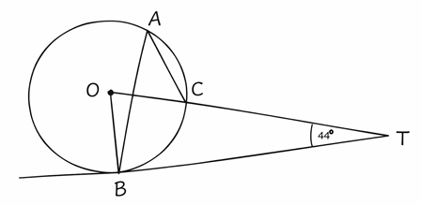
Figure 1
Find the value of angle BAC (5 marks)

- The area of two similar triangles BCD and XYZ are 100cm² and 256cm² respectively. If the length of XY is 16 cm, calculate the length of BC. (5 marks)

- If $\vec{AB}$ = $\left({6 \atop 4}\right)$ and $\vec{AC}$ = $\left({-4 \atop 2}\right)$, calculate the midpoint of $\vec{BC}$. (5marks)

- Figure 2 shows a solid cone of base radius OC = 7cm and a slanting height AC = 21cm.
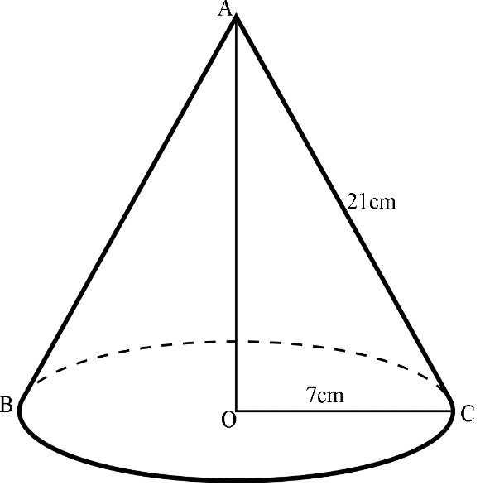
Figure 2
Calculate the total surface area of the cone. (6 marks)

- A pond 12m in diameter has a shape of hemisphere and is full of water. The pond is emptied and all the water poured into a cylindrical tank of radius 5m. Assuming there is no loss of water, calculate the height of water in the tank. (Volume of a sphere = $\frac{4}{3}πr^{3}$) (6 marks)

- The second term of a geometric progression is 10 and the fifth term is 640. Calculate the sum of the first five terms. (6 marks)

- If $\left(4x^{2}-9\right)\left(mx+d\right)$ is identical to $16x^{3}+24x^{2}-9xm-54.$ Calculate the values of $m$ and $d$ (5 marks)

- Table 1 below shows ages and frequencies of girls in a school choir.

Age in years | 14 | 15 | 16 | 17
Frequency | 3 | 4 | 5 | 4
Table 1

Calculate the mean age of the girls in the school choir, giving your answer correct to 1 decimal place. (5 marks)

- Figure 3 below shows domain and range of a mapping $f:x→\frac{x-2}{2x-3}$

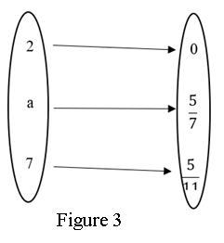

Calculate the value of $a$ (4 marks)

- If $\tan{θ}$ = $\frac{12}{5}$ , find the value of $\frac{\sin{θ + 2\cos{θ}}}{1 - \sin{θ}}$ (5 marks)

- Figure 4 shows a triangle XYZ with its image X′Y′Z′

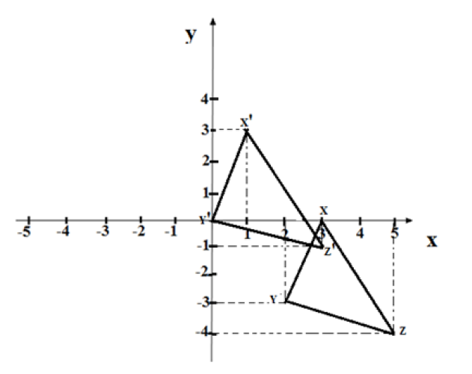
Figure 4

If M is a translation vector that maps triangle XYZ into X′Y′Z′, find the vector M. (4 marks)

- A quantity P varies directly as q and inversely as the cube root of r. When p = 10 and q = 5 then r = 8. Find P when q = 54 and r = 27 (6 marks)

- Figure 5 is a speed – time graph of an object.
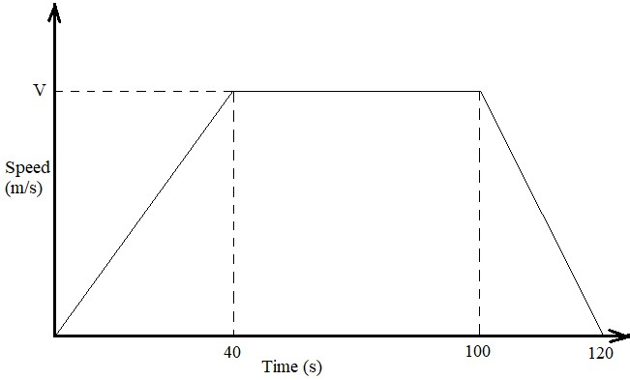
Given that the total distance travelled by the object is 7200m, calculate the acceleration in the first 40 seconds. (4 marks)

- Make $u$ the subject of the formula $A= \frac{1}{2 }m (v^{2}- u^{2})$ (4 marks)

- On the graph paper provided, sketch the region described by the following inequalities by shading the unwanted region: $≤0, x+y<10 and x-2y≥0$ . (5 marks)

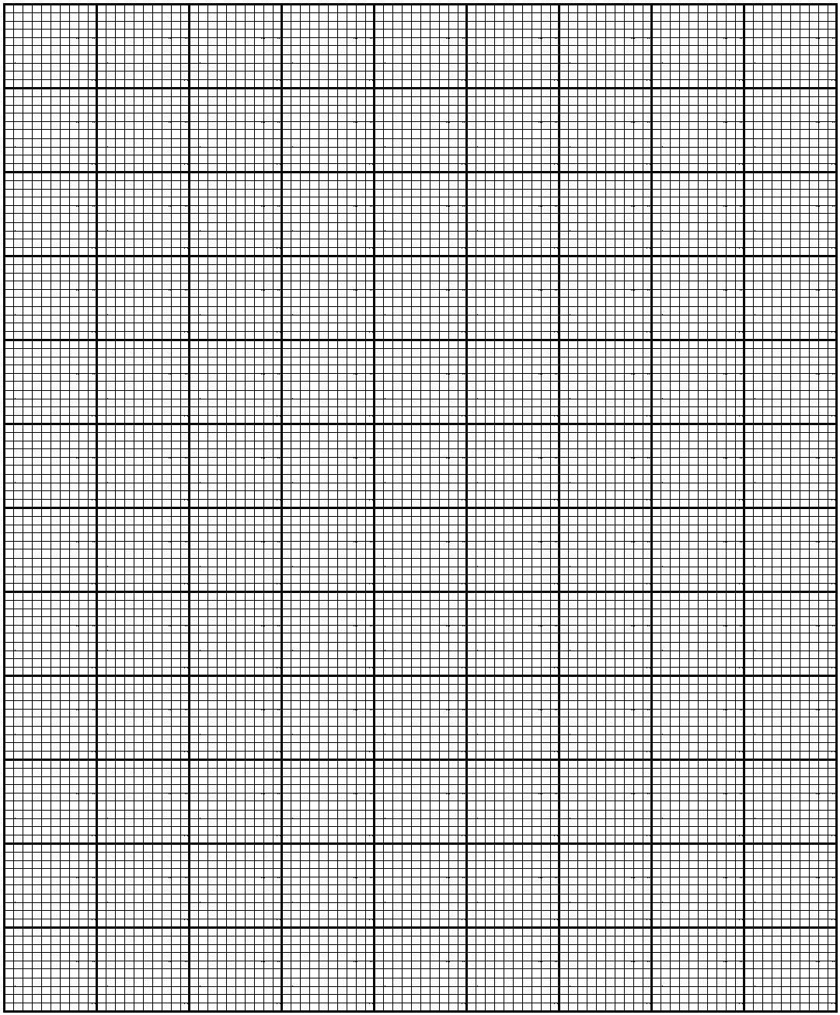

END OF QUESTION PAPER

